Thomson Reuters Court Management Solutions

Contents

Contents 2

I. Requirements 3

II. Installation Instructions 3

# Requirements

The following requirements must be met before following the steps in this document:

* For system requirements please refer to <https://www.adlibsoftware.com/support/documentation/adlibpdfenterprise/6.0/en/adlib_help.htm>
* A version of C-Track or E-file which supports AdLib OEM must be installed prior to the AdLib installation
* A current AdLib license
* The user installing AdLib must have administrative privileges on the application server.
* A Microsoft SQL Server Database and user with owner privileges which will be used by the Adlib service
* Microsoft Word must be installed on the AdLib server if you are supporting Word documents
* The following Server Roles, Services, or Features must be installed using the Add Roles and Features Wizard
  + - Internet Information Services (IIS)
    - ASP.NET 3.5 (may not be available by default on Server 2016)
    - ASP.NET 4.5/6go
    - HTTP Activation
* IIS 6 Management Compatibility

# Installation Instructions

1. Disable User Account Control
   1. Open Server Manager  
      
   2. Click on “*Tools*” on the menu on the left  
      
   3. Click on “*Local Security Policy*”  
      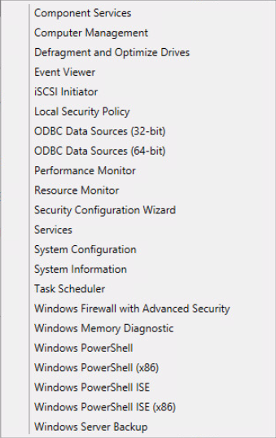
   4. Click on Security Settings > Local Policies > Security Options  
      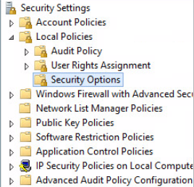
   5. Scroll down to the User Account Control section  
      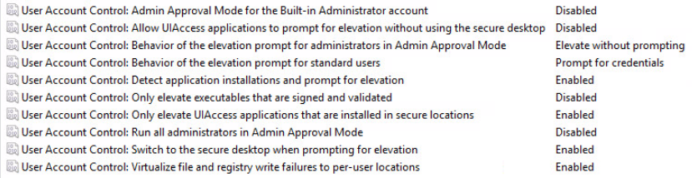
   6. Ensure the following settings are “*Disabled*”
      1. User Account Control: Admin Approval Mode for the Built-in Administrator account
      2. User Account Control: Allow UIAccess applications to prompt for elevation without using the secure desktop
      3. User Account Control: Only elevate executables that are signed and validated
      4. User Account Control: Run all administrators in Admin Approval Mode
   7. Ensure the following settings is set to “*Prompt for credentials*”
      1. User Account Control: Behavior of the elevation prompt for standard users
   8. Open Control Panel  
      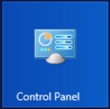
   9. Click on “*User Accounts*”  
      
   10. Click on “*User Accounts*”  
       
   11. Click on “*Change User Account Control settings*”  
       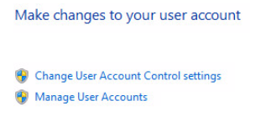
   12. Set the notification level to “*Never notify*”  
       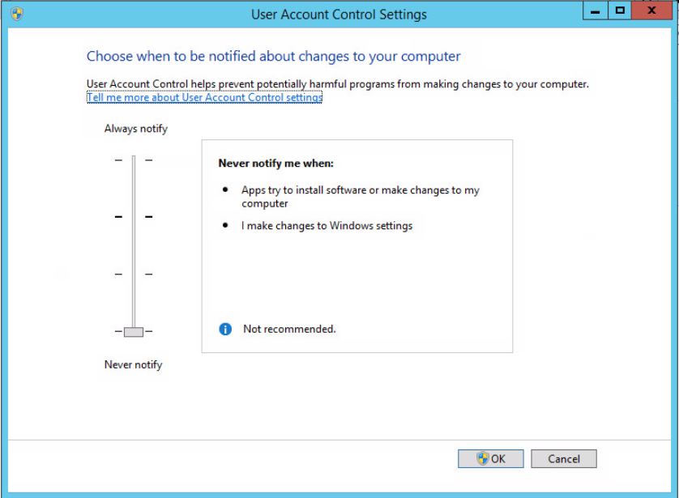
   13. Restart your machine for the settings to take effect

Note: This procedure does not always produce complete results on Windows 2016. It is a best practice to confirm these changes in the registry using the following procedure:

1. Open the Windows Registry Editor: Start > Run; regedit
2. Navigate to the following Registry Key:   
   HKEY_LOCAL_MACHINE\SOFTWARE\Microsoft\Windows\CurrentVersion\Policies\System
   1. If you do not have this key, you can create it
3. In the right pane, modify the value of the “*EnableLUA*” DWORD value to “*0*”
   1. If you do not have this DWORD value, you can create it
4. Restart your machine
5. Downloading and Preparing for AdLib 6 Software Installation
   1. Download Adlib Enterprise from https://www.adlibsoftware.com/Software/adlibpdf.enterprise.6.0.2.exe
   2. From the courtapps.com SFTP server, download adlib-registration.zip and PreReq_Check.zip
   3. Unzip the PreReq_Check.zip file and run PDF-PreReqCheck.exe as Administrator
6. Installing AdLib 6 Software
   1. Right mouse click on the AdLibPDF.OEM.64Bit.6.0.2.exe file and run as Administrator.  
      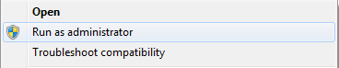  
        
      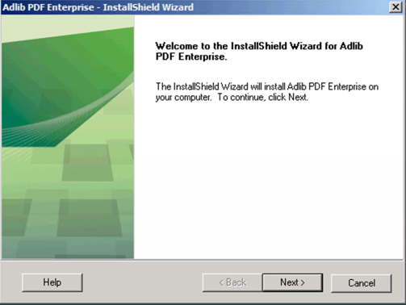
   2. In the Customer Information window, type the Username and Company Name and click Next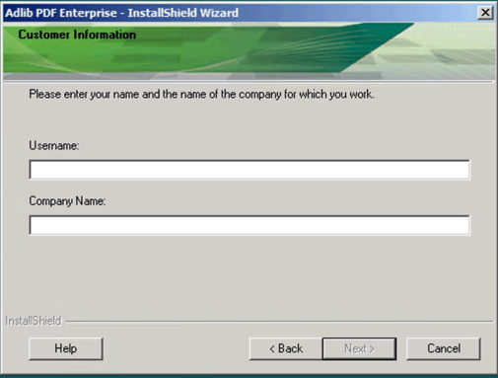
   3. In the Setup Type window, select *Custom* and then click *Next*.
      1. If desired, click Browse… and select an alternate Installation Folder for the installation.   
           
         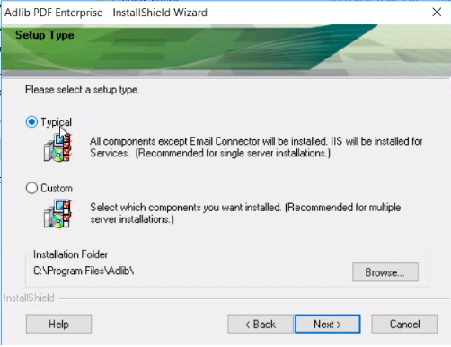
      2. The specified installation folder will be checked to ensure that the user NETWORK SERVICE has the required permissions to allow IIS to access the web.config in the install folder. If the proper permissions have not been set, a pop-up dialog will provide the following options: Yes: The install will attempt to change the permissions. If it fails to set permissions, the installation will fail. If successful, the install will continue. No: The install will not attempt to change permissions if not set. The user will be prompted to select a different installation path. Ignore: The installer will check for permissions and note in install log if required permissions are not set. The installation will continue.
   4. Select the components you wish to install in the Select Features window. The disk space required/available for the selected components will be displayed. The following options are available:
      1. **Database Scripts**: The scripts and support files required to create the Adlib System Database.
      2. **Services**: The Job Management Service and the services required to run the Adlib Management Console. Select IIS or Self-Hosted. If IIS is selected, the Job Management Service will be deployed inside IIS. If Self-Hosted is selected, these services will be deployed within an Adlib created web server.
      3. **System Manager**: The component that manages jobs and monitors all Adlib System components. System Manager also prepares each job by executing the appropriate rule sets and issues alerts to the system administrator.
      4. **Transformation Engine**: The component that performs file transformations. Folder Connector: A Connector whose Source type is one or more file folders. A Connector is a type of component that monitors a Source for content and submits it as a job to the Adlib System. A Connector also receives completed job output. Email Connector: A Connector whose Source type is one or more POP Inboxes.  
         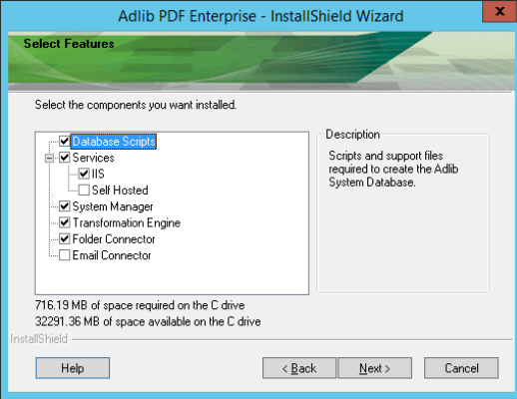
   5. In the Management Console Login Settings window, type the Password you wish to use to login to the Adlib Management Console. Enter the Email Address at which you wish to receive system notifications and click Next.
      1. Note: The Username for these administrator-level credentials is predefined as “sysadmin” remember to keep this password safe but not written down or easily accessible.  
         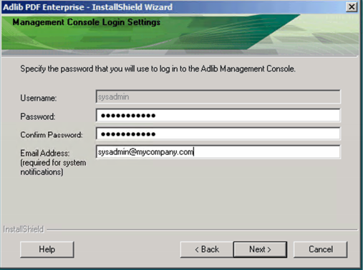
   6. Enter or modify the default values for the following fields in the SQL Server Database Settings window and click Next:
      1. **Database Name**: Any alias for the name of the database to be used by Adlib PDF.
      2. **Server Name**: The machine name where the database is located. This must be an externally visible/resolvable name.
      3. **Username/Password**: The credentials of a database user with read/write privileges. These credentials will be used to register components and to make calls to the database.
      4. **Use Windows Authentication**: Check the box to set the authentication for SQL Server to Windows Authentication. The user performing the installation, as well as the NT_AUTHORITY\SYSTEM and NT_AUTHORITY\NETWORK SERVICE must have sysadmin privileges in the database.
      5. The information provided in the Database Settings window will be used to verify a connection to the database before the remainder of the installation can proceed.
      6. Note: Before providing all these details the DB should be created with the name (Adlib_PDF) in the Database server.  
         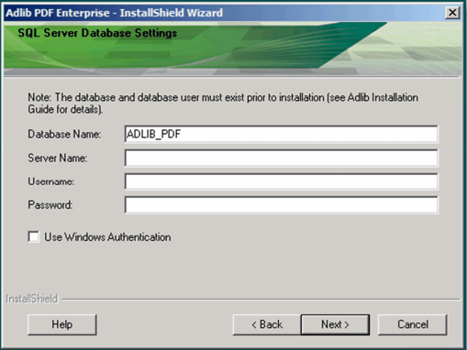
   7. If desired, modify the default path in the Root Adlib Work Folder window. This is the location where the working folders will be created as necessary for the components being installed.  
      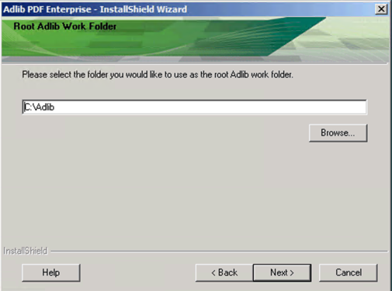
   8. In the Windows Credentials window, type the Account and Password under which the Adlib executables and services will run. These must be the credentials of a Windows user with local host privileges. The Account name must be in the local admin\username or domain\username format. For example: Local admin\username format: AdministratorDomain\username format: mydomain\adlibuser.
      1. Note: User Account Control security settings must be turned off for this Windows user before the installation of Adlib PDF.
      2. This user must also have permissions to run as a Windows Service.
         1. Launch Local Security Policy and expand Local Policies, click on User Rights Assignment. On the right, scroll down to 'Log on as a service' and ensure the defined Adlib Service Account is listed under Security Setting.   
            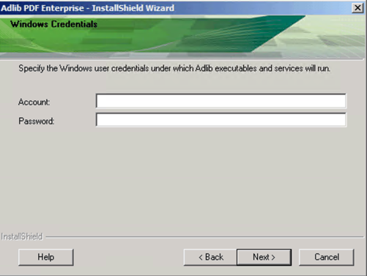
   9. IIS Services (or a Typical installation) was selected, complete the following fields:
      1. **IIS Port Number**: The port number for the user console connection to the Adlib website.
      2. **IIS Authentication Settings Account/Password**: The credentials of a user with the right to create Internet Information Services Settings, using the domain\username format.
      3. **Create a local Job Folder**: An IIS virtual directory and a shared path will be created for use by the System Manager.
      4. **Use Existing Job Folder**: Select this option if you are configuring a clustered environment.
      5. Note: Mention the port no which is required to host the adlib. We have used 51050 instead of 80.  
         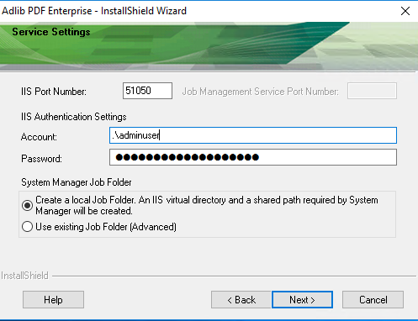
   10. In the Start Copying Files window, review the list of components that will be installed. If any changes are required, click Back to make changes.
   11. Click Next to begin copying the program files. The software will install using the settings defined during the installation process.  
       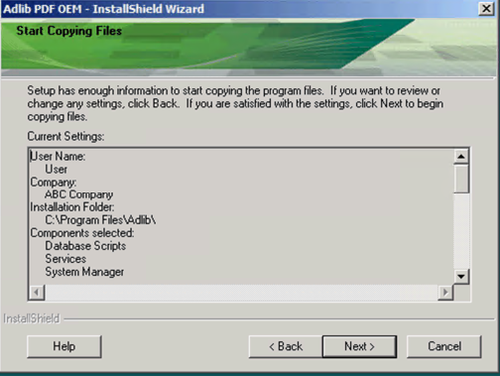
   12. In the InstallShield Wizard Complete window, select the appropriate checkbox if you wish to view the Installation Log and or launch the License Manager and click Finish. The Installation Log is stored in the Windows temp folder. To access the Installation Log, ensure you are logged in as the user who performed the installation and navigate to the temp folder in Windows Explorer using the following syntax: %temp%.
7. Activating License
   1. In the final page it will show to upload the Licence-key. Once it is done restart the Adlib Process Manager service.
8. Check If WSDL File Is Accessible
   1. From a browser enter this URL <http://localhost:51050/Adlib/JobManagementService/JobManagementService.svc?wsdl>
      1. The browser should return something like this:  
         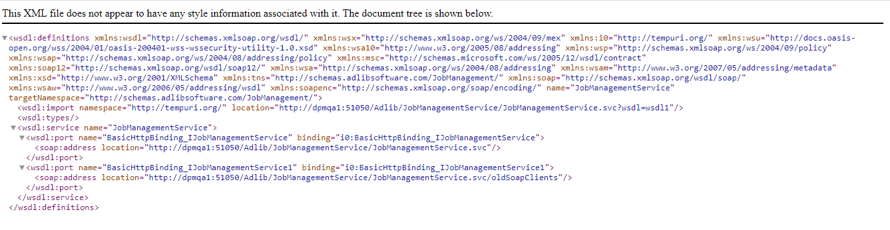
9. Registering AdLib

*The following steps need to be performed on the C-Track and/or E-File application server.*

* 1. Modify your Windows Hosts file (C:\Windows\System32\drivers\etc\hosts) to include an entry for the Adlib server
  2. From a browser, try to access the WSDL you tested in Step 5.1, replacing localhost with the server name you provided in the hosts file in the previous step.
  3. Unzip the adlib-registration.zip file into the C-Track and/or E-File folder on the Tomcat server
  4. Verify the adlibregistration/etc/adlib-registration.properties file and make appropriate modifications to match your environment
  5. Open a command prompt window as an administrator
  6. In the command prompt, run the adlibRegister.bat script (found in adlibregistration\bin)
  7. If successful, the script will generate an adlibApplicationConfig.properties file and an application-data.sql file
     1. For E-file you can cut and paste the output into application.properties. For C-track edit the contents of the property file by removing the leading word “conversion” so change conversion.adlib.property to adlib.property on each line. Then copy and paste into your application.properties file.
  8. You will also need to add the WSDL to the application.properties as well for E-file or C-Track;  
     E-File example;

conversion.adlib.serviceLocation=http://<YourAdlibServer>:51050/Adlib/JobManagementService/JobManagementService.svc?wsdl

C-track example;

adlib.serviceLocation=http://<YourAdlibServer:51050/Adlib/JobManagementService/JobManagementService.svc?wsdl

* 1. Restart Tomcat

1. Configuring AdLib

*The following steps should be run on the AdLib server*

* 1. Launch Internet Explorer
  2. Navigate to the following URL: <http://localhost:51050/Adlib/UI/Adlib.UI.html#/Login>
  3. Enter the Administrator’s credentials that you created during installation and click *Submit* to login  
     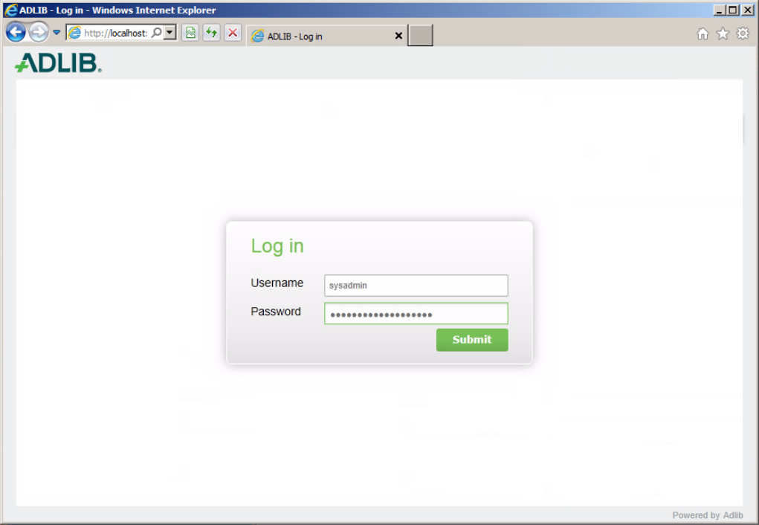
  4. Click on System Settings  
     
  5. Click on the □ in the Configure menu option on the upper right.  
     
  6. Click on Process Manager  
     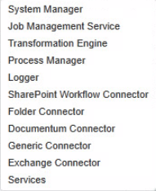
  7. Click on *Edit*  
     
  8. Click on the □ in the Component Settings section  
     
  9. Click on Process Manager and hold down the right mouse button  
     
  10. Drag Process Manager to the Common section on the right-hand side of the screen  
      
  11. Click on the □ in the Component Settings.Process Manager section on the right  
      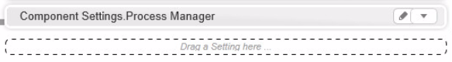
  12. Click on Edit  
      
  13. Click on the □ in the Session section  
      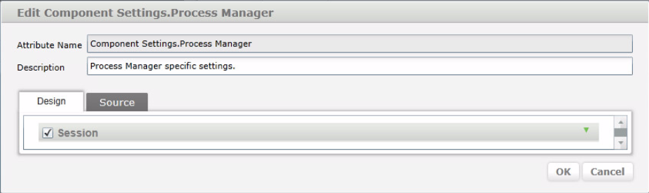
  14. Place a check in the box next to port & Acknowledge Interactive Logon Message and set the value to true and click on OK.  
      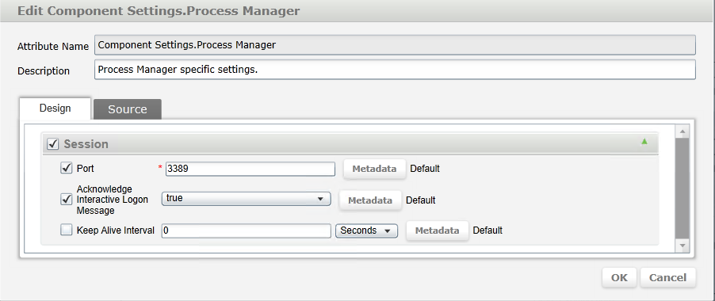
  15. Click on Save  
      
  16. Click on  next to System Settings  
      
  17. Click on the □ next to Action  
      
  18. Click on Publish  
      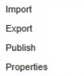

1. Enabling OCR
2. Click on the **job setting** -> click **configure** in the drop down click **Transformation rules**, Click edit in the setting tab search for OCR. In the below tab will find the OCR logo drag to default section click save.

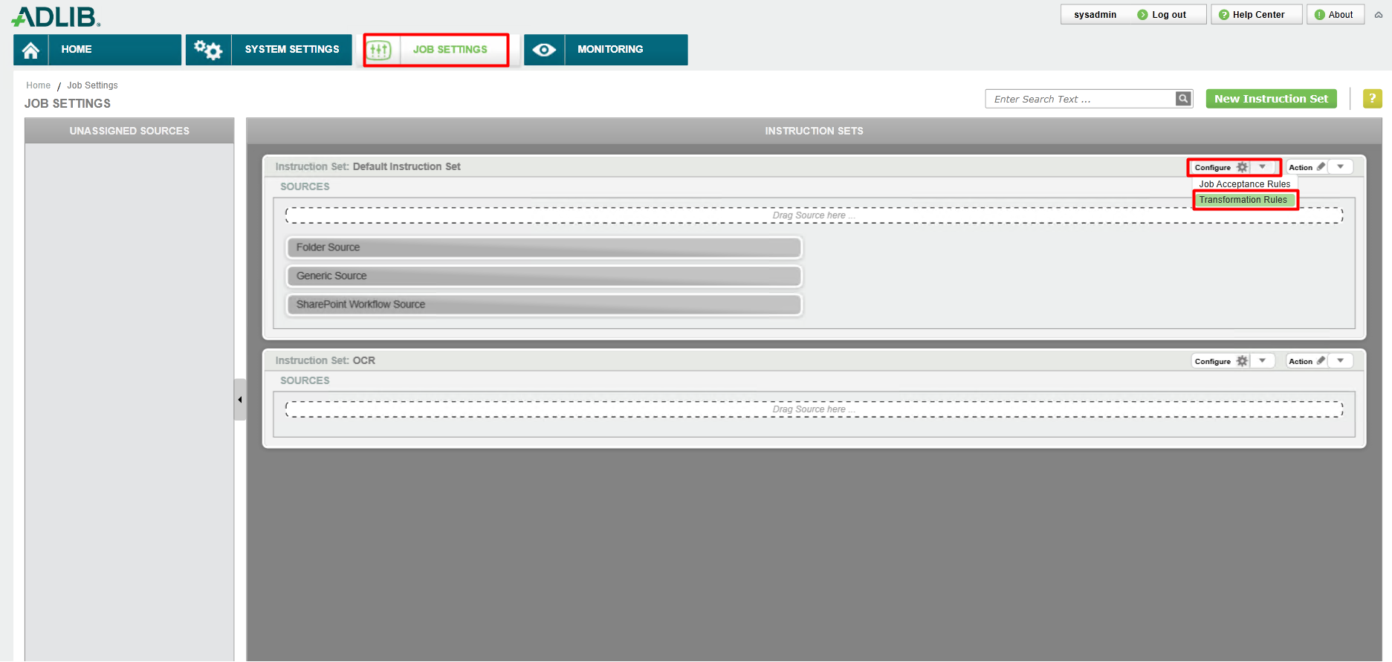

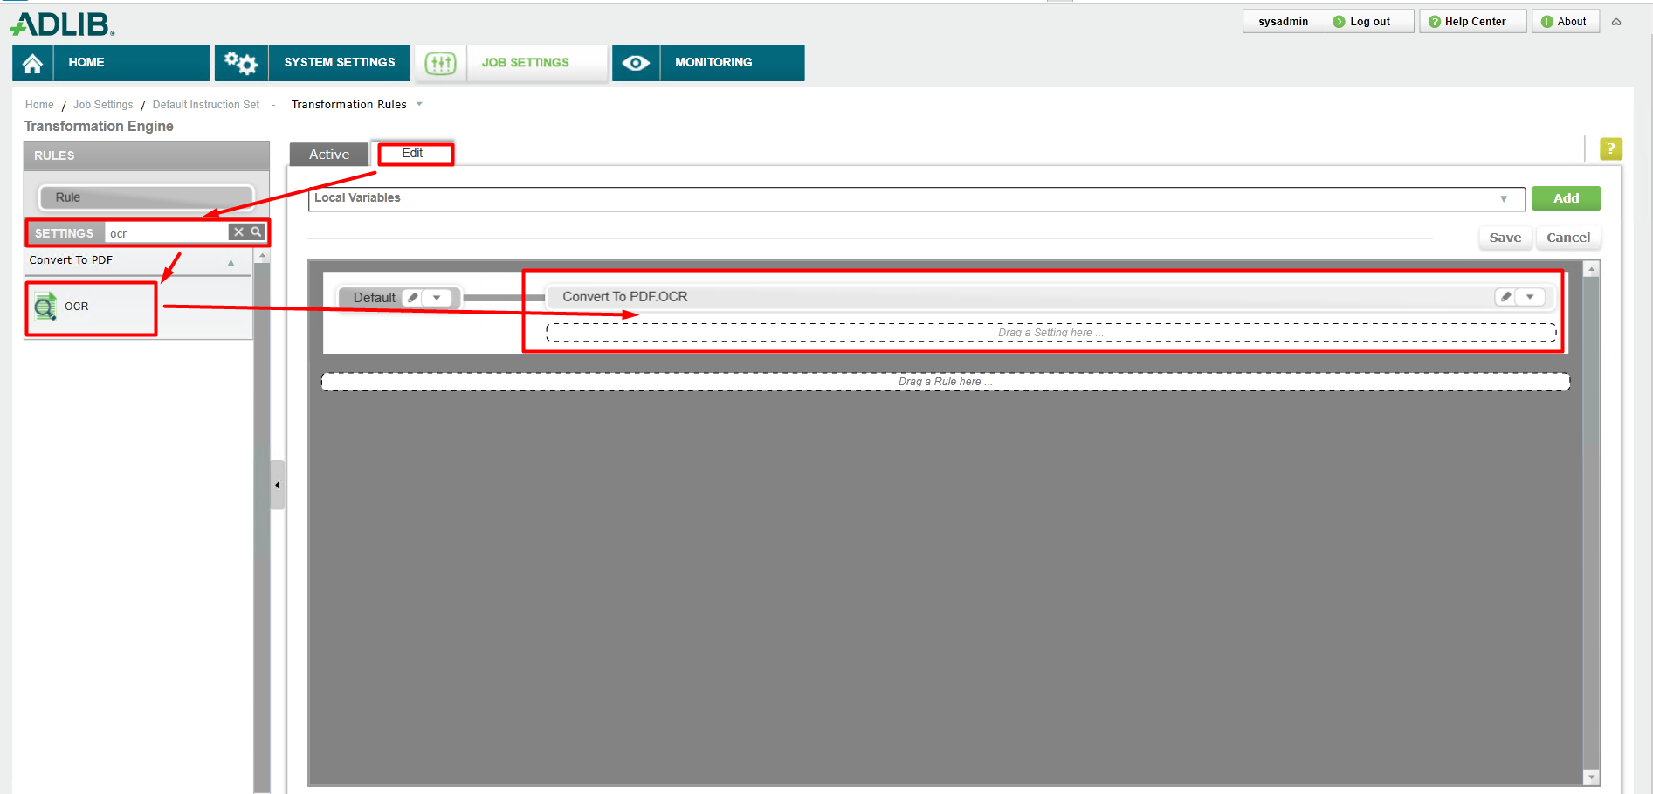

1. Finally click on the JOB SETTING below that click on **Action** click **Publish**

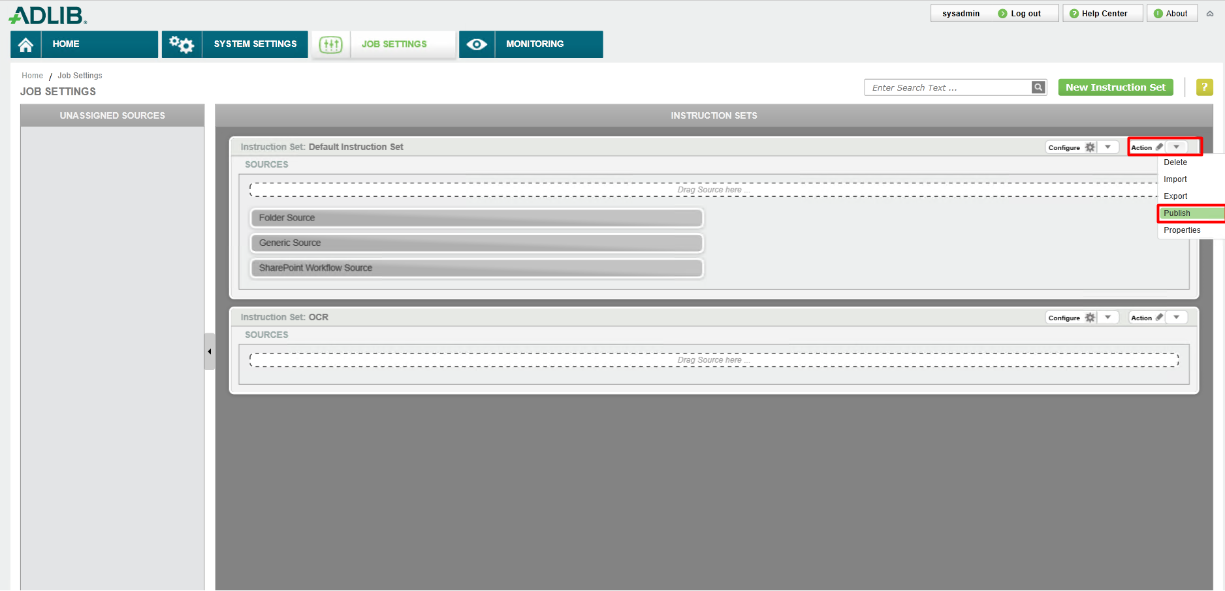

1. Testing AdLib
   1. Launch C-Track or E-File
   2. Upload a Word and/or PDF Document